**Tsunami**

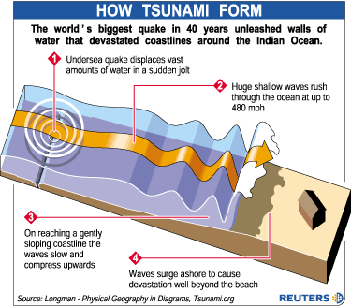A tsunami is a series of great sea waves caused by an underwater earthquake, landslide, or volcanic eruption. More rarely, a tsunami can be generated by a giant meteor impact with the ocean.

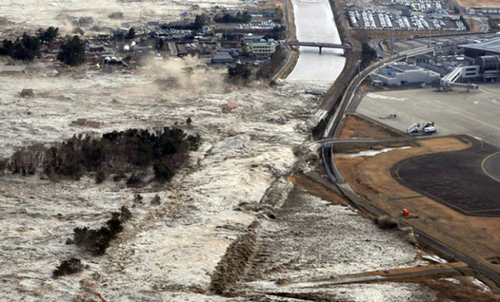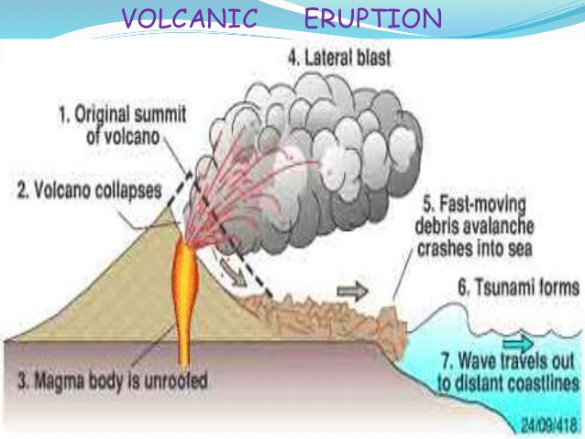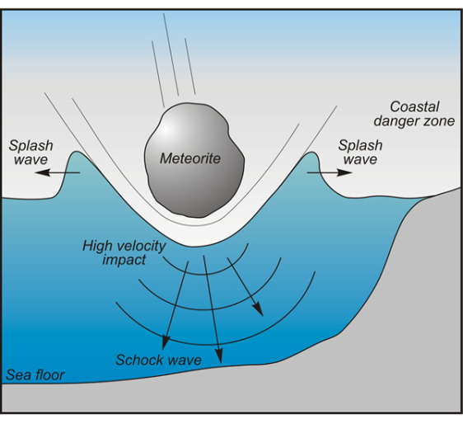

A tsunami is a huge wave, usually caused by volcanic or earthquake activity under the ocean, which can eventually crash onto the shoreline. The effects on a community can be devastating.

Case study: Boxing Day Tsunami, 2004

On 26 December 2004 a tsunami occurred in the Indian Ocean. It was the result of the Indio-Australian Plate subducting below the Eurasian Plate. It was caused by an earthquake measuring more than magnitude 9. The earthquake caused the seafloor to uplift, displacing the seawater above.

In open ocean the tsunami measured less than 1 metre high.

The tsunami travelled at speeds up to 800km per hour.

When the Tsunami reached the shores, the height of the wave increased to 15 metres in some areas.

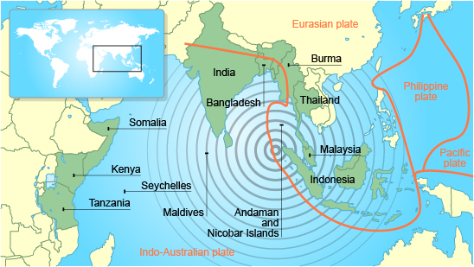

Task 1: Explain each of the ways a tsunami can be formed. You may wish to add a scientific diagram to your explanations.

Task 2: Tsunamis are the hardest disaster to detect.

How far do you agree with this statement based on everything you have read today?

Main impacts

A quarter of a million people died.

Two million people were made homeless.

People were swept away in the waters, which arrived rapidly and with little warning.

Thirteen countries were affected, the worst being Indonesia.

Indonesia was hit by the tsunami first. Fourty-five minutes later the tsunami reached Thailand.

Mangrove swamps helped to act as a barrier to reduce the energy of the water in some areas.

Short-term aid, such as water purification tablets, temporary housing and medical supplies were given from international countries.

Islands reliant on tourism and fishing, such as the Maldives, had to rebuild their industries.

An early warning system between countries surrounding the Indian Ocean has been set up.

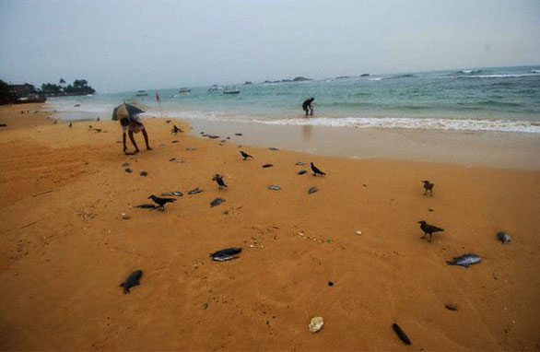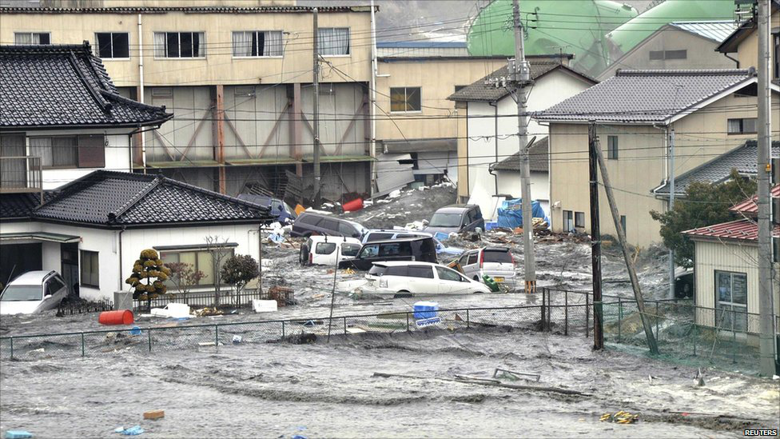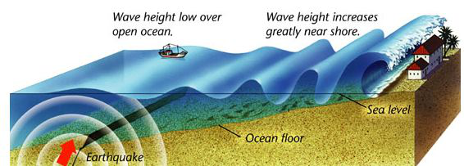

**What effects does a tsunami have?**

The main impact a tsunami has is flooding. The waters are also able to erode the foundations of coastal structures.

It is hard to see that a tsunami is approaching. The most obvious sign is the coastal water retreats just before the waves reach the shore. This is actually the trough of the wave following behind.

**What causes a Tsunami?**

When an earthquake, volcano or landslide happens on the ocean floor, water is displaced. This water forms the start of the tsunami.

When the waves reach shallower water:

Their height can increase by several metres

The shallow water slows the wave

The waves get closer together