English – Writing Project

This week we would like you to write an explanation for a ‘Cracking Contraption”.

Watch the following video:
https://www.youtube.com/watch?v=gu2pxJo3cI0

Here is my explanation for the Soccamatic:

How the Soccamatic machine works

The smashing Soccamatic contraption was invented by Wallace in order to defeat Gromit's unbeatable record of saved goals. This is how the marvellous machine works:

First, the Soccamatic machine is positioned directly in front of the football goal. When the goalie is ready to begin and the shooter is comfortable in the chair, the petrol engine is started. As a result, this drives the motor which is attached to four rotating spokes. A football boot is attached to the end of each spoke.

Next, the footballs are released one at a time quickly down the chute. As a ball rolls down to the bottom of the chute, the rotating boot makes contact with the ball and consequently kicks it into the goal at high speed.

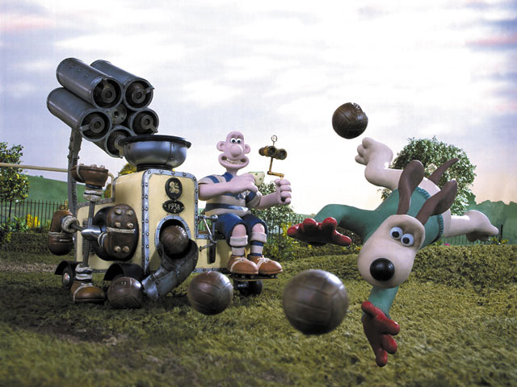
Finally, if the Soccamatic becomes empty and runs out of footballs then a lever is pulled. This raises a metal container full of new footballs and empties them into the opening at the top, therefore it can continue firing.

The Soccamatic has proven to be very popular with many animated characters in the plasticine world. Wallace is now able to beat the highly skilled defender, Gromit, and is very proud his cracking contraption has been shown to a human audience. Remember: 'All the goals, none of the fuss!'

Features of an explanation text:

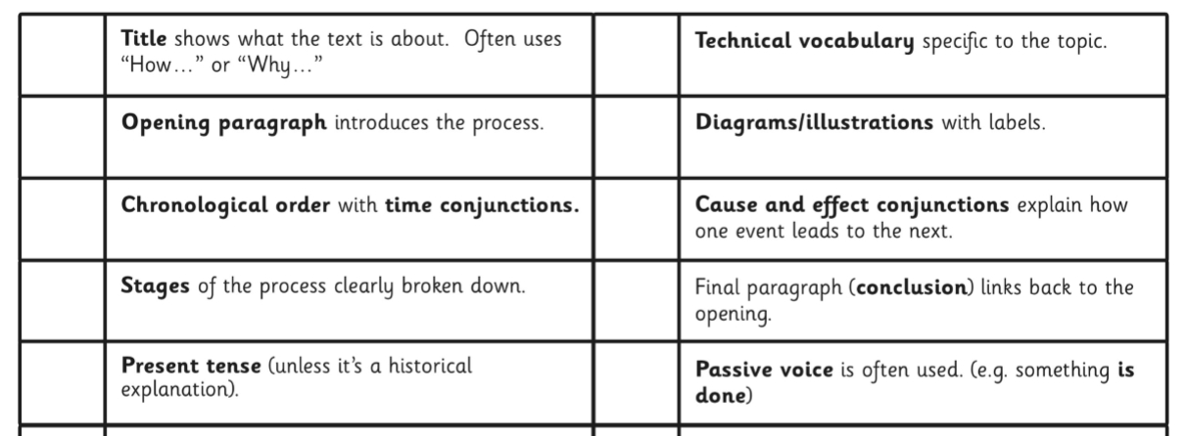

Can you spot any of the features in my explanation?

Now it is your turn – watch the following ‘Cracking Contraption’ videos. https://www.youtube.com/watch?v=jknWm0FLWbw
Choose one of them to write your own explanation of how it works. Write it up in your home learning book and please share with us at ARHyear5@aldermanrichardhallam.leicester.sch.uk Have fun!

