**The Sea – by James Reeves**

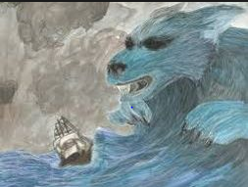The sea is a hungry dog,   
Giant and grey.  
He rolls on the beach all day.  
With his clashing teeth and shaggy jaws  
Hour upon hour he gnaws  
The rumbling, tumbling stones,   
And 'Bones, bones, bones, bones! '  
The giant sea-dog moans,   
Licking his greasy paws.  
  
And when the night wind roars  
And the moon rocks in the stormy cloud,   
He bounds to his feet and snuffs and sniffs,   
Shaking his wet sides over the cliffs,   
And howls and hollos long and loud.  
  
But on quiet days in May or June,   
When even the grasses on the dune  
Play no more their reedy tune,   
With his head between his paws  
He lies on the sandy shores,   
So quiet, so quiet, he scarcely snores.

Retrieval

1. Which animal is the poet describing the sea as? **A hungry dog**
2. Find and copy a word that rhymes with loud. **cloud**
3. Which months are quiet? **May and June**

Inference

1. What do you think the sea is doing when it is described as a dog rolling on the beach all day?

**The tide going in and out – waves/water rolling like a dog on the beach.**

1. Find and copy a phrase that shows that the water is pushing and moving the stones:

**The rumbling, tumbling stones.**

Comparison

1. How has the sea’s behaviour changed from the second stanza to the third stanza?

Explain your answer, with reference to the text:

**The sea has calmed down and is no longer rough - “he lies on the sandy shores, so quiet, he scarcely snores.**