**Maths – Lesson 3**

Today you are going to look at percentages of measures. Look at the following website to explore percentages. [www.topmarks.co.uk/Flash.aspx?f=PercentageFractionChains](http://www.topmarks.co.uk/Flash.aspx?f=PercentageFractionChains)

Click on length, weight and/or money then write an amount to start e.g. £80. Can you calculate the different percentages? Click on 10% then 50% to reveal the quantities then reveal the remainding percentages. How did you get on? Have a go with as many measures and amounts until you feel confident.

Now it is your turn to make your own percentage bubbles in your worker books. Good luck!

1. 100% = £120
2. 100% = 500kg
3. 100% = 90m

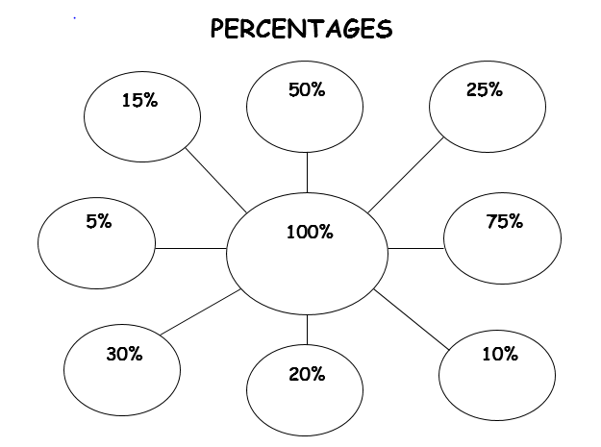

Finally you can check your answers using the website again. [www.topmarks.co.uk/Flash.aspx?f=PercentageFractionChains](http://www.topmarks.co.uk/Flash.aspx?f=PercentageFractionChains)