Maths Key Skills Stage 5: Skill Check 12 Answers

Name: ___________________________________ Date: _______________ Class/Group: _______________________________

A: Place Value, Add and Subtract |  | B: Multiply, Divide and Fractions |  |  | C: Measure, Geometry and Statistics
1. What is the value of the 7 in this number? 7,186,354 | 5:1  7,000,000  (million) | 11. Write all of the factors of 26. |  | 5:8  1, 2, 13, 26 | 21. If 4 litres is approximately 7 pints, about how many litres are equal to 21 pints? |  | 5:20  12
2. Put these in order, smallest first: 1,012,685 99,956 867,600 1,300,423 | 5:1  99…, 867…, 1012…, 1300… | 12. Which of the following are prime numbers? 17 21 23 25 27 |  | 5:9  17, 23 |  |  | 5:20  12
3. Round 596,147 to the nearest ten thousand. | 5:2  600,000 | 13. 4,170 ÷ 6 |  | 5:10  695 | 22. Calculate the area of this rectangular field:  25m  10m |  | 5:21  250m²
4. What is the missing number?  53,450 54,450 56,450 | 5:2  55,450 | 14. 1.04 x 100 |  | 5:11  104 |  |  | 5:21  250m²
5. Put these in order, smallest first:  -10, -3, -2, -7, -9, -6 | 5:3  -10,-9,-7, -6,-3,-2 | 15. What is 1³ ? |  | 5:12  1 |   23. Reflect the shape in the mirror line. |  | 5:28  Shape drawn
6. What year is represented by these Roman Numerals? MMIX | 5:4  2009 | 16. Put these in order, smallest first:  5  6  16  18  8  12  2  8 |  | 5:13  8 5 16  12 6 18 |  |  | 5:28  Shape drawn
7. 212,190 – 14,085 = | 5:5  198,105 | 17. Find an equivalent fraction of . |  | 5:14  1  4 | 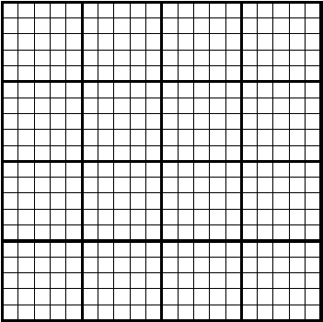  24. Rose recorded her height each year:  Height (cm)  140  135  130  125  0  Between  which two  7 8 9 10  Age  ages did  Rose grow  the most?  25. How much taller was Rose at the age of 10 than when she was 7? |  | 5:29  8 and 9  5:29  13cm
8. 63,460 + 17,175 = | 5:5  80,635 | 18. Write the answer as a mixed number.  12  15  6  15  + |  | 5:15  3  15  1 |  |  | 5:29  8 and 9  5:29  13cm
9. Complete this sum without written working. 20,500 - 6,200 = | 5:6  14,300 | 19.  5  11  x  =  44 |  | 5:16  20 |  |  | 5:29  8 and 9  5:29  13cm
10. The temp. was -9°C. It rose by 8°C, then dropped by 10°C. What is it now? | 5:7  -11°C | 20. Write 0.83 as a fraction. |  | 5:17  83  100 |  |  | 5:29  8 and 9  5:29  13cm
Total (A) |  | Total (B) |  |  | Total (C)
Test Total (A+B+C) |  | R (0-9) | Y (10-19) |  |  | G (20-25)

