Stage 3 Maths Assessment Test 4

Name: Class: Date:

Raw Score (40): Criteria Score (30): Level Awarded:

A Place Value

1. What is 100 less and 100 more than 183?

183
100 less 100 more

1 mark (3:1)

2. Circle the numbers where the digit 7 has a value of 7 hundreds (700).

175 745 127 72 715 179

1 mark (3:2)

3. Fill in the missing parts of the table.
The first one has been done for you.

Number | In Words
312 | Three hundred and twelve
 | Two hundred and eighty
192
 | Seven hundred and seven

2 marks (3:3)

4. What number is the arrow pointing to on the number line below?

50
150
100

1 mark (2:3)

5. Use all of the digits below to write the smallest and largest number possible.

2
9
7

smallest largest
2 marks (3:5)

B Add and Subtract

6. Add 10 to each of the numbers below.
91 164 609

1 mark (3:6)

7. Calculate 837 – 369

You must show your working.

2 marks (3:7)

8. Sam says that 25 + 72 = 97.

Fill in the boxes below to show a subtraction sum we can use to check that Sam is correct.
- = 72

1 mark (3:8)

9. Use 25 + 14 = 39 to help solve this sum.

390 - 140 =

1 mark (3:9)

C Multiply and Divide

10. Draw all the missing lines. One has been done for you.

56 ÷ 8 11

44 ÷ 4 7

Twenty seven divided by three 12

96 ÷ 8 8

32 ÷ 4 9

2 marks (3:10)

11. Use: 7 x 6 = 42 to help complete the following number sentences

70 x 6 = 420 ÷ = 7

1 mark (3:11)

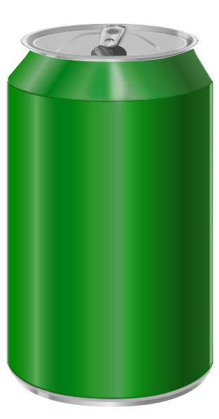
12. Cans of pop come in packs of 6.
Freddie needs 26 cans for a party.
How many packets should he buy?

1 mark (3:12)
D Fractions

13. Write the missing fractions in this sequence.
6
10
5
10
3
10

1 mark (3:13)

14. Here are 16 sweets.
3
4
Circle of the sweets.
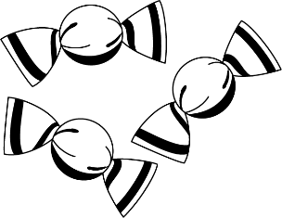
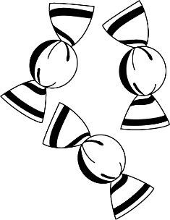

1 mark (3:14)

15. What fraction is the arrow pointing to on the number line below?

0
1

1 mark (3:4)

16. This shape is divided into six (6) equal parts.
1
6
Each part is of the whole shape.
1
3
Shade of this shape.

1 mark (3:16)
17. Subtract the fractions.
3
5
2
5
- =

1 mark (3:17)

18. Write these fractions in order of size, starting with the largest.

1
8
1
2
1
6
1
4

largest smallest
1 mark (3:18)

E Measure

19. Sarah weighed some pieces of fruit on a set of scales.

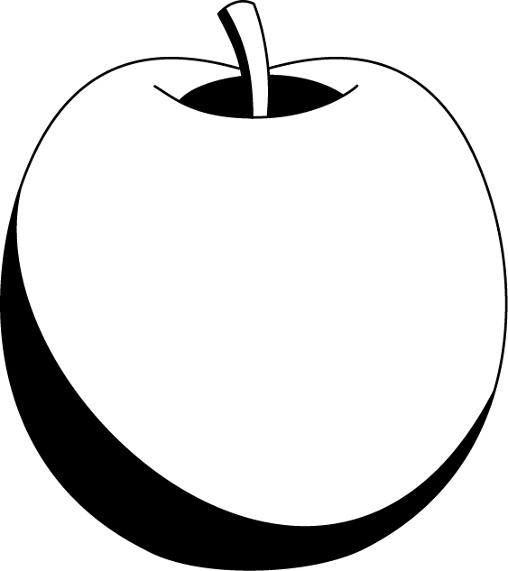
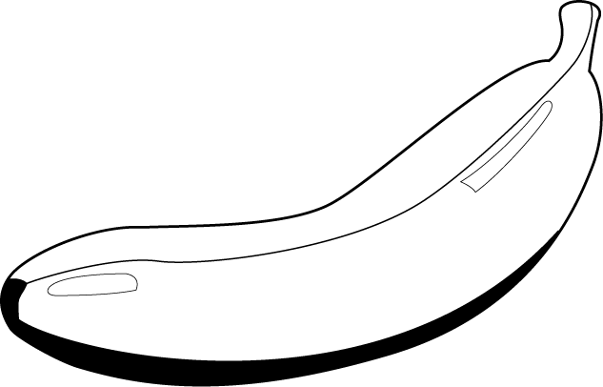

0
20
40
60
80
100
120
140
160
180
200
grams

80
100
120
60
140
160
40
grams
20
180

0
200

Use the diagrams above to calculate how much the banana weighs.

g

1 mark (3:20)

20. What is the perimeter of this rectangle?

5cm

cm

14cm

1 mark (3:20)
21. Kirsty has £4.
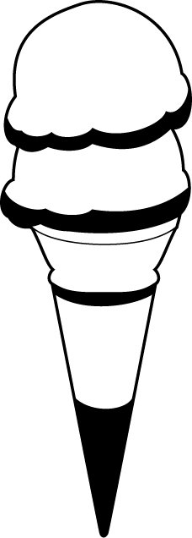
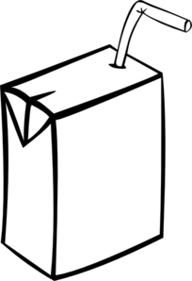
At the shop she buys a carton of drink for 50p and an ice cream for 95p.
How much change will Kirsty have left?

£____ and ____p

2 marks (3:21)

22a. Write the time below as it would b. Write the time below as it would
appear on a 24-hour clock. appear on a 12-hour clock.
You must circle if it is a.m. or p.m.
A B
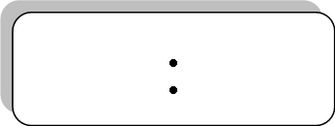
12 hour clock
12 hour clock
11
10 pm
am
am
pm

24 hour clock
24 hour clock
06
15

2 marks (3:22)

23. About how long does it take to have a shower?

Tick (✓) the best estimate.

about 10 seconds about 1 minute

about 10 minutes about 1 hour

1 mark (3:23)

24. Circle the months that have 30 days.
March April May June

1 mark (3:24)
F Geometry

25. Name the 3D shape that is being described here.

I have 6 faces, 8 vertices and 12 edges.

1 mark (3:25)

26. Scott is facing shop A.
He turns to face shop B.
How many degrees has he turned through?

A
B

°

1 mark (3:26)

27. The dial below is currently pointing to 1.
It is turned clockwise through a series of right angles.

0
1
7

2
6

3
5
4

What number will the dial be pointing to after being turned through the following?

1 right-angle 2 right-angles 3 right-angles 4 right-angles

2 marks (3:27)
28. Draw lines to join the words to the diagrams that represent them.

perpendicular
parallel
horizontal
vertical

2 marks (3:28)

G Statistics

29. Class 4 did a survey to find out how many pupils had a dog or a cat. The results are displayed in the table below.

 | Dog | Cat | Both | Neither
Boy | 3 | 4 | 2 | 4
Girl | 2 | 3 | 5 | 1

a. How many girls have a cat?

b. How many boys don’t have a cat or a dog?

2 marks (3:29)

30. Use the table above to answer these questions.

a. How many fewer boys own dogs than own cats?

b. How many girls are in Class 4 in total?

2 marks (3:30)

