Stage 2 Maths Assessment Test 4

Name: Class: Date:

Raw Score (40): Criteria Score (30): Level Awarded:

A Place Value

1. Write the missing numbers in this sequence.

0 4 6
1 mark (2:1)

2. What is the value of the 3 and the 7 in the number 73?

3 7
1 mark (2:2)

3. Draw an arrow on the number line below to show the number 7.

5
15
10

1 mark (2:3)

4. Write <, > or = to make the number sentences correct.

5 + 12
17

24
28
1 mark (2:4)
5. Fill in the missing parts of the table.
The first one has been done for you.

Number | In Words
25 | Twenty five
 | Thirty four
42
 | Ninety eight

2 marks (2:5)

B Add and Subtract

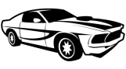
6. Three friends compare how many toy cars they have.
Tom has 4 toy cars.
Rory has 5 more than Tom.
Louise has 2 less than Rory.
How many toy cars does Louise have?
Show your working out.

2 marks (2:6)
7. Complete the number sentences below.

8

20
- + =

b) + =
16

40
2 marks (2:7)
8. Add the scores on each set of dice below to find the total score.

(a) Total score =

(b) Total score =

2 marks (2:8)

9. Tick the statements which are true.
6 + 7 = 7 + 6
21 - 3 = 3 - 21
4 - 1 = 1 - 4
13 + 9 = 9 + 13
1 mark (2:9)

10. Use this sum to help you fill in the missing numbers below: 35 + 19 = 54

19

35

a) - =

54

35

b) - =

2 marks (2:10)

C Multiply and Divide

11. Complete these division sums from the five (5) times table.
30 ÷ 5 =
÷ 5 = 13
2 marks (2:11)
12. Write the symbols x (multiply), ÷ (divide) or = (equals) to make the statements below correct.

- 7 8 56

b) 24 6 4

2 marks (2:12)

13. Tick (✓) the statements which are true.
12 ÷ 6 = 6 ÷ 12
4 x 9 = 9 x 4
4 ÷ 24 = 24 ÷ 4
11 x 3 = 3 x 11

1 mark (2:13)

14. A train has six (6) carriages. Each carriage holds twelve (12) passengers.
How many passengers can the train carry in total?
Show your working out.

2 marks (2:14)
D Fractions
3
4
15. Colour in more squares so that exactly three quarters ( ) of the shape is shaded.

1 mark (2:15)

16. Fill in the missing number to make these equivalent fractions.

2
2
4
=

1 mark (2:16)

E Measure

17. What temperature is shown on this thermometer?
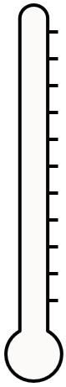
7°C
6°C
5°C
4°C

3°C
2°C
1°C
0°C
-1°C

-2°C
-3°C

°C

1 mark (2:17)

18. Put the following animals in order of their mass, starting with the smallest.
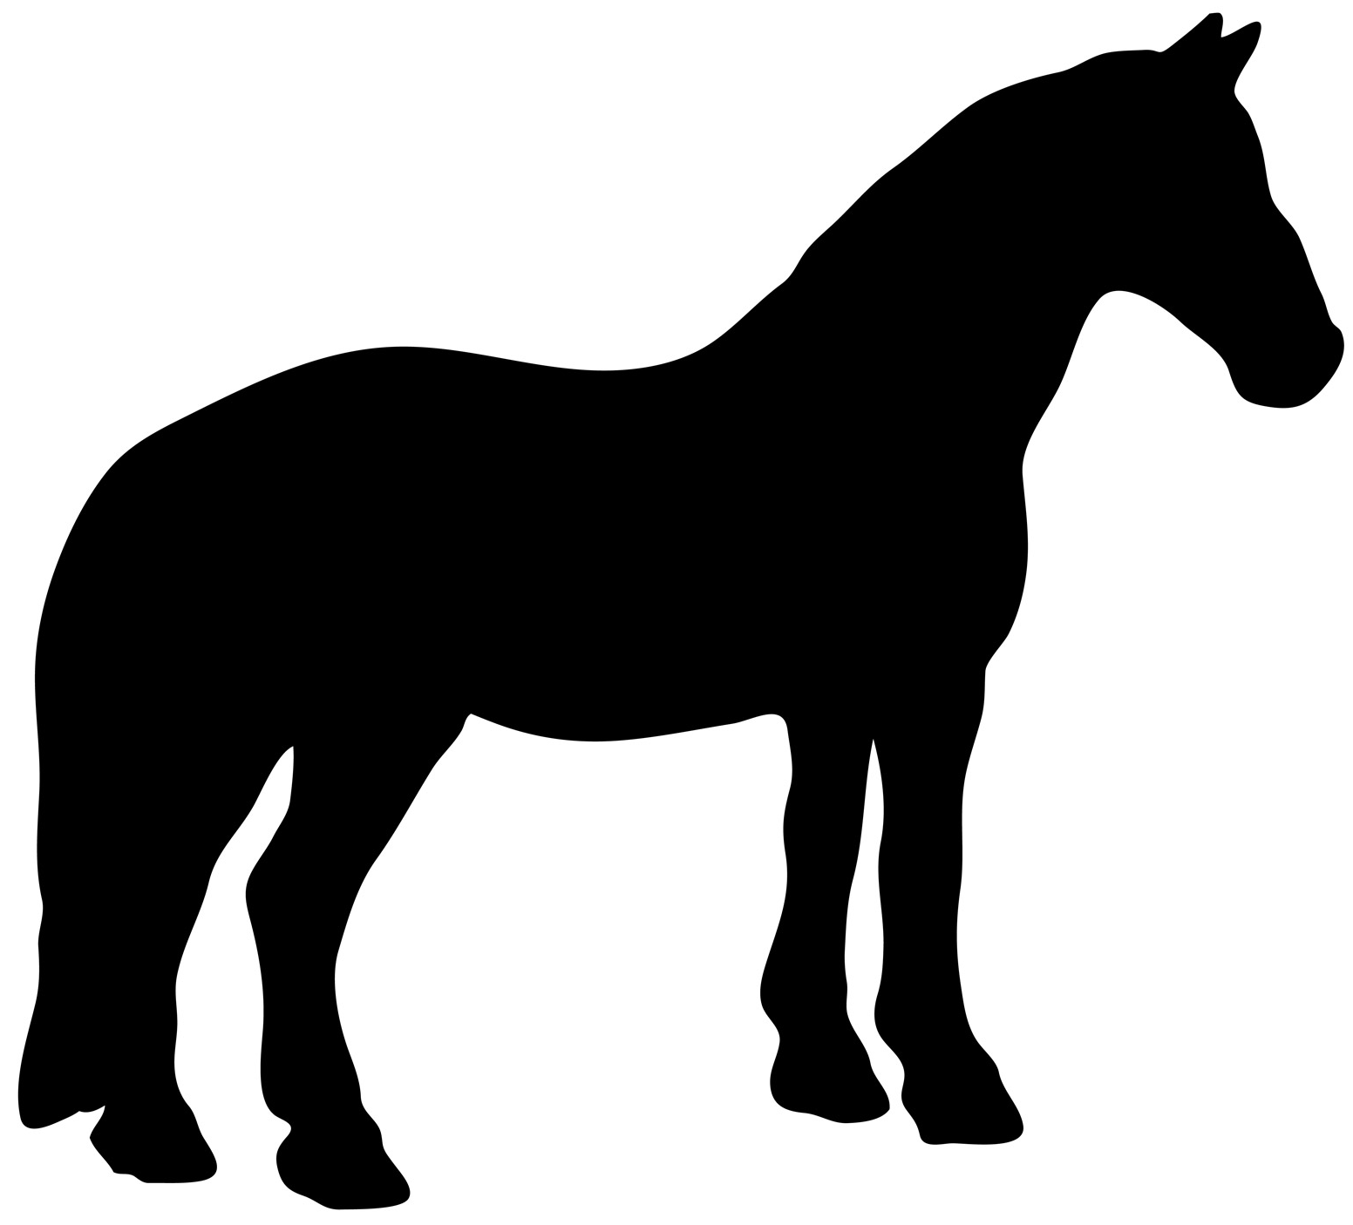

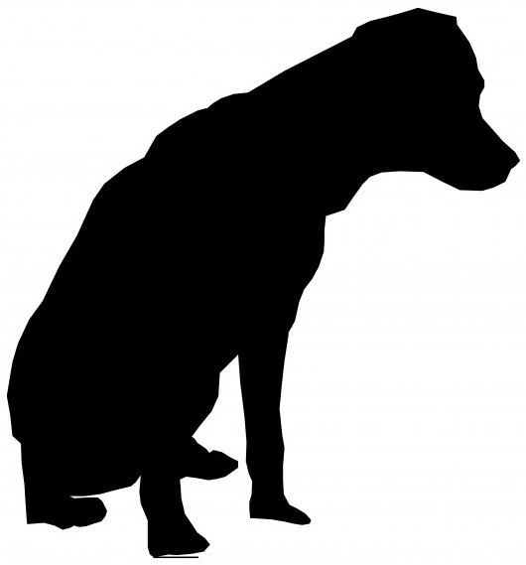

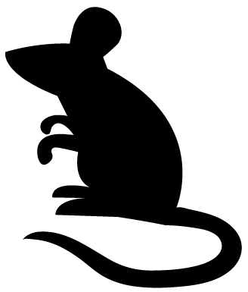

Dog
Horse
Mouse

In order:
smallest

1 mark (2:18)

19. In a shop, Fred needs to pay 75p.
In the spaces below write three coins that he could use to make 75p.

p

p

p

, and

1 mark (2:19)

20. Robert buys a comic book from a shop for £1.30.
He pays with a £2 coin. How much change should he get?
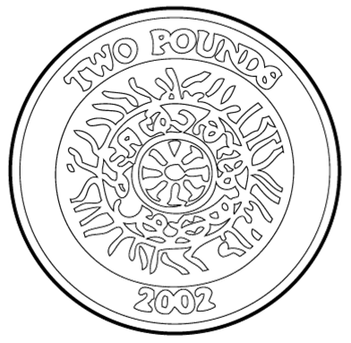

p

1 mark (2:20)

21. Write a, b, c and d to sort these periods of time from shortest to longest.

a. 1 day b. 45 minutes c. 5 hours d. 50 seconds

shortest longest

1 mark (2:21)

22. Write the times that these clocks show.

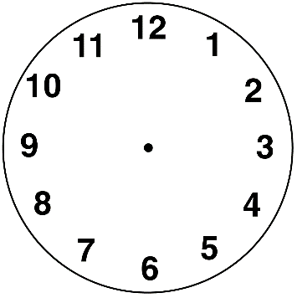
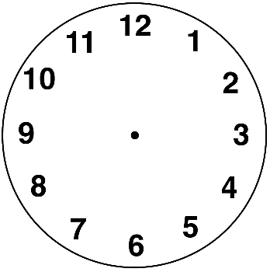

2 marks (2:22)

F Geometry

23. How many sides do the following shapes have?
sides
Square
sides

Circle

1 mark (2:23)

24. Write numbers in the boxes below to describe a cube.

A cube has:

faces, edges and vertices.

1 mark (2:24)

25. A square based pyramid has faces which are two different shapes. What are they?

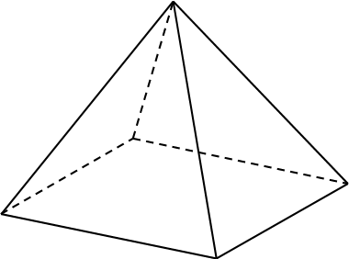
square

1 mark (2:25)

26. Pick two (2) shapes that have something in common and explain what it is.

A B C

Shapes: ____ and ____

Reason: ___________________________________________

2 marks (2:26)

27. Here is a pattern of shapes. Draw the next shape in the pattern.

1 mark (2:27)

28. If I turn this dial through half a turn, which number will it be pointing at?
0
2
1
4
3
6
5
7

1 mark (2:28)

G Statistics

29. The block diagram below shows the favourite sports of a class of children.

6
5
4
3
2
1
 | Football | Rugby | Tennis | Hockey
5 children chose Hockey.
Colour in the block diagram to show this.
1 mark (2:29)

30. Looking at the block diagram above, which sport was the most popular?

1 mark (2:30)

