Stage 2 Maths Assessment Test 3

Name: Class: Date:

Raw Score (40): Criteria Score (30): Level Awarded:

A Place Value

1. Write the missing numbers in this sequence.

0 5 15
1 mark (2:1)

2. Circle the numbers where the digit 8 has a value of 8 units.
18 8 80 82 28 89
1 mark (2:2)

3. Estimate the number that the arrow is pointing to on the number line below.

0
20
10

1 mark (2:3)

4. Put the following numbers in order, starting with the smallest.

65
37
28
17
81

smallest
1 mark (2:4)
5. Fill in the missing parts of the table.
The first one has been done for you.

Number | In Words
25 | Twenty five
37
 | Fifty six
88

2 marks (2:5)

B Add and Subtract

6. Rosie rolls two dice and adds the scores together.
She rolls a third dice. Her total score is now 12.
What was the score on the third dice?
Show your working out.

2 marks (2:6)

7. Complete the number sentences below.

8

10
- + =

b) + =

20
100
2 marks (2:7)
8. Complete the number sentences below.

(a) 35 + 9 =

(b) 78 - 30 =

2 marks (2:8)

9. Tom says, “It doesn’t matter what order you subtract two (2) numbers in. You get the same answer both ways”.
Show that Tom is not correct.

1 mark (2:9)

10. Use this sum to help you fill in the missing numbers below: 18 + 27 = 45

45

18

a) - =

18

27
b) - =

2 marks (2:10)

C Multiply and Divide

11a. Complete these multiplication facts from the two (2) times table.

7 x 2 = , x 2 = 24

11b. Complete this statement about the two (2) times table using the word odd or even.
All numbers in the two (2) times table are

2 marks (2:11)
12. Write numbers 24, 8 or 3 in the boxes to make these correct.
8

3
- x =

b) ÷ =

2 marks (2:12)

13. Laura says, “When you multiply two (2) numbers together, you will get different answers depending on the order you do it in”.
Show that Laura is not correct?

1 mark (2:13)

14. 18 strawberries are shared between a group of friends.
They each get 3 strawberries.
How many friends were there?



friends

1 mark (2:14)
D Fractions

15. Write the fractions described here in words.
The first one has been done for you.
1
2
One half

Two thirds Three quarters
1 mark (2:15)

16. What is a third ( ) of 15?
1
3

of 15 =
1
3

1 mark (2:16)

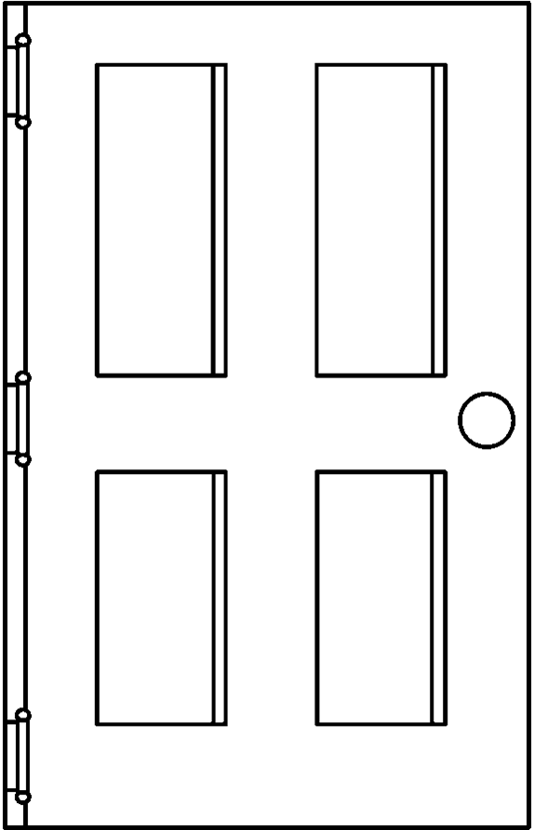
E Measure

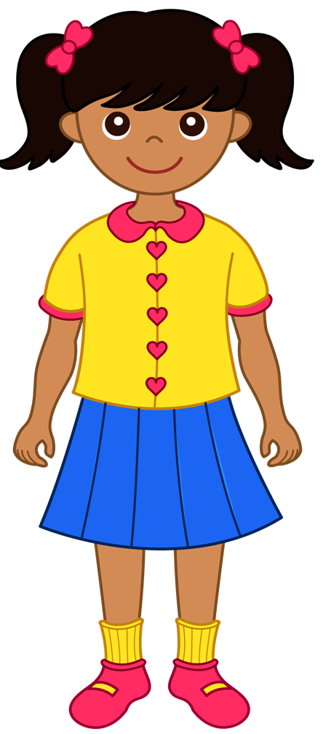
17. Choose the correct units to complete Molly’s sentence.

centimetres metres millimetres

The height of the classroom door is about 2 .
1 mark (2:17)

18. Choose the correct symbol to make the statement below correct.
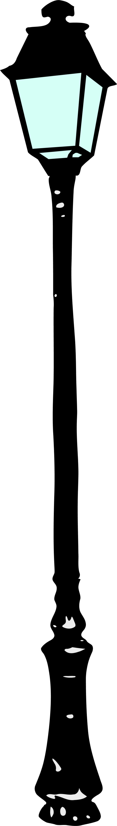
Write the symbol in the box.



< > =

The height of a post-box
the height of a lamppost.

1 mark (2:18)

19. How much money is here? Give your answer in pounds (£).
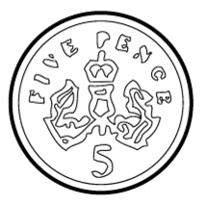
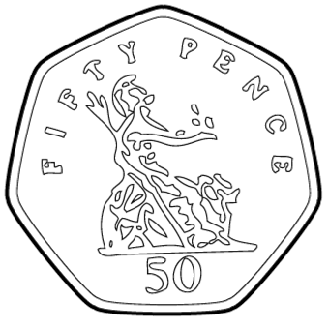
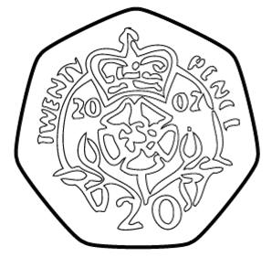

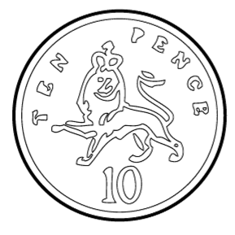

1 mark (2:19)

20. Thomas has three (3) 50 pence coins.
He spends 60p in the shop.
How much money does Thomas have now?

p

1 mark (2:20)

21. Write a, b, c and d to sort these periods of time from shortest to longest.

a. 2 weeks b. 5 days c. 24 hours d. 1 month

shortest longest
1 mark (2:21)

22. Draw hands on the clocks to show the times below.

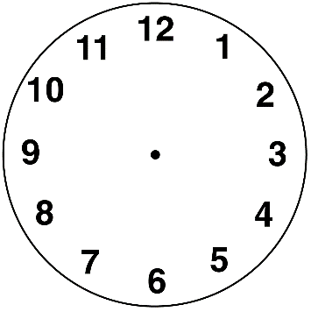
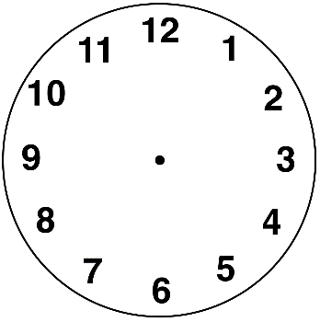

Quarter to 4.
Ten minutes past one.

2 marks (2:22)

F Geometry

23. How many sides do the following shapes have?
sides
Pentagon
sides

Triangle

1 mark (2:23)
24. Write numbers in the boxes below to describe a square based pyramid.

A square based pyramid has:

faces, edges and vertices.

1 mark (2:24)

25. Tick () the 3D shapes which have a face that is a quadrilateral.
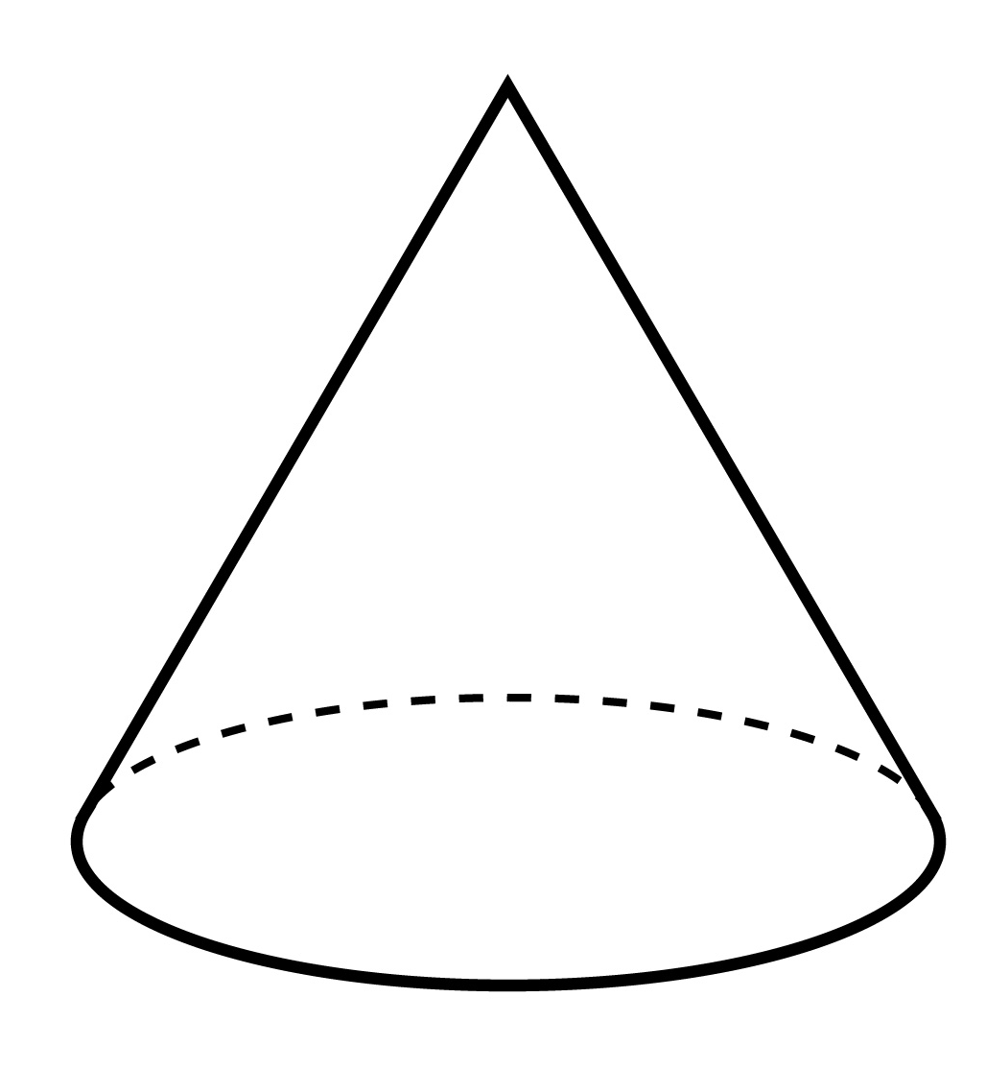

1 mark (2:25)

26. Which shape is the odd one out?

You must give a reason for your answer.

A B C

Odd one out: ____
Reason: ___________________________________________
2 marks (2:26)

27. Here is a pattern of shapes.

Tick () the shape that will continue the pattern.

1 mark (2:27)
28. Steven was facing North East (NE).

Steven turned anti-clockwise through one right angle.

In what direction is Steven facing now?
NW
North (N)
South (S)
East (E)
West (W)
NE
SW

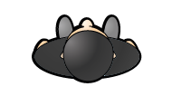

SE
1 mark (2:28)

G Statistics

29. The block diagram below shows the favourite crisp flavours of a class of children.

6
5
4
3
2
1
 | Plain | Salt and Vinegar | Cheese and Onion | Prawn Cocktail

How many more students chose cheese and onion than prawn cocktail?

1 mark (2:29)
30. Using the block diagram above, put the crisp flavours in order starting with the most popular.

Most popular Least popular
1 mark (2:30)

