Year 2 Topic- Habitats

1. Look at the powerpoint about animals and their habitats. Choose an animal to draw and write about the habitat they live in. (You can draw more than one if you like!)
2. Use the sheet to design your own animal and explain what habitat they need and why.

1. Look at the minibeasts powerpoint and see what interesting facts you can find. Write down some of your favourite ones!
2. Draw some pictures of your favourite minibeasts.
3. 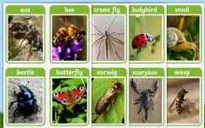Look at the minibeast recording sheet. Make a similar one in your book and see which ones you can find and where. Why did you find them in these places?

